Store Clerk User Guide

Team 8

**Table of Contents**

**Logging Into the System** **3**

**Product Catalogue (Store Department)** **3**

Browse Product Catalogue 3

Select list of stationery 4

Edit Stationery Details 4

Remove Stationery 4

View Stationery Stock Card Details 5

Add a New Stationery 5

**Supplier List** **6**

View Supplier List 6

View list of stationery supplied by a particular supplier 6

**Department Details** **7**

View Department details 7

Edit Department Details 7

**Purchase Orders** **8**

Find Purchase Orders 8

Purchase Order Details 9

Create Purchase Order 9

**Inventory Management** **11**

Receiving Inventory from suppliers 11

Withdrawing items for weekly disbursement 12

Generate and view the Consolidated Request Form 13

View Inventory 14

View Low Stock Inventory 14

**Disbursement List** **15**

Finding Disbursement Lists 15

**Create Adjustment Voucher** **18**

Create Adjustment Voucher Form 18

**Stationery Trend Analysis and Prediction** **19**

# 

# Logging Into the System

The system will be accessed via the below page. User is to enter the provided credentials into the username and password boxes.

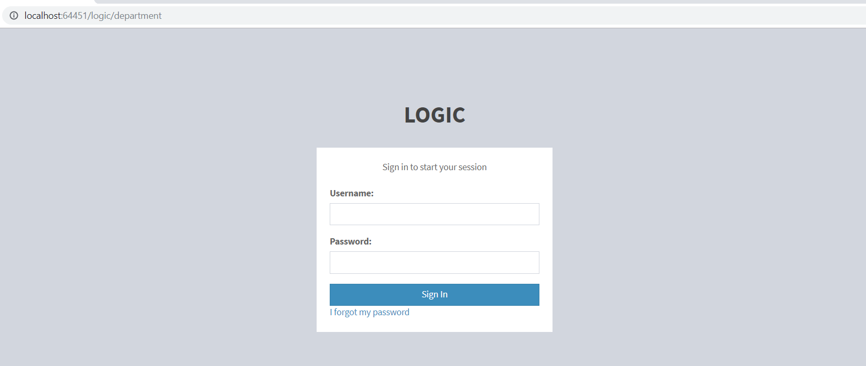

# Product Catalogue (Store Department)

## Browse Product Catalogue

On the side bar menu, click on the ‘Product Catalogue’. It will lead to the lists of the category of the stationery.

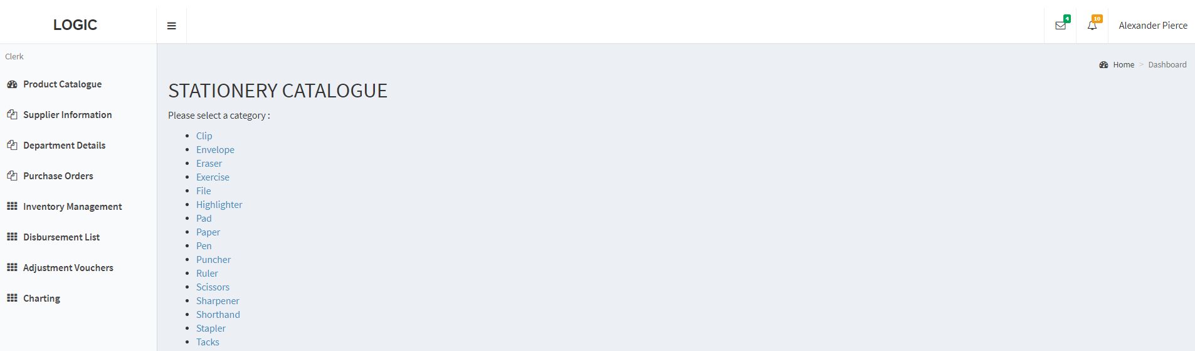

## Select list of stationery

To view the list of the stationery, click on one of the categories and it will lead to the whole list of stationeries belong to that category.

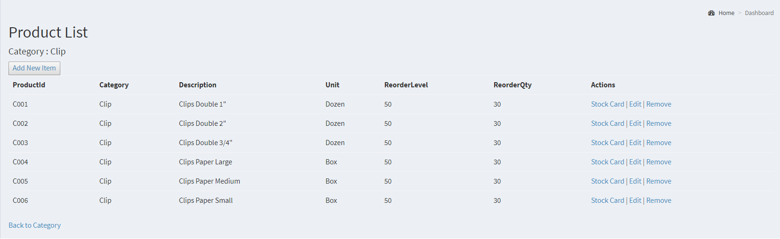

## Edit Stationery Details

On the right hand side of each stationery, there will be options for user to choose. User will be able to edit or modify a particular stationery detail.

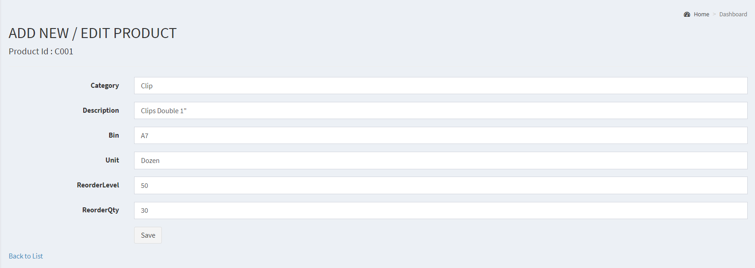

## 

## Remove Stationery

User will also be able to remove the stationery when this stationery are no longer sold by any of the suppliers.

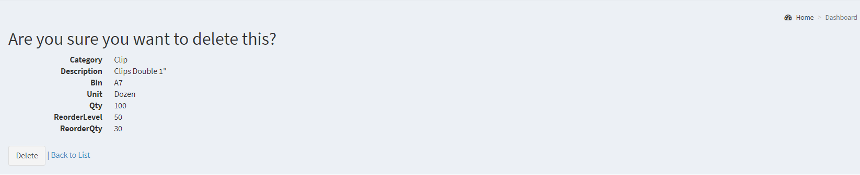

## View Stationery Stock Card Details

User is able to check the movement details and the latest quantity of this particular stationery from the stock card. Another information user is able to obtain from the stock card are:

1. List of suppliers who supply this item. It is arranged according to the rate supplied by supplier.

2. The stationery location (eg. Bin A7).

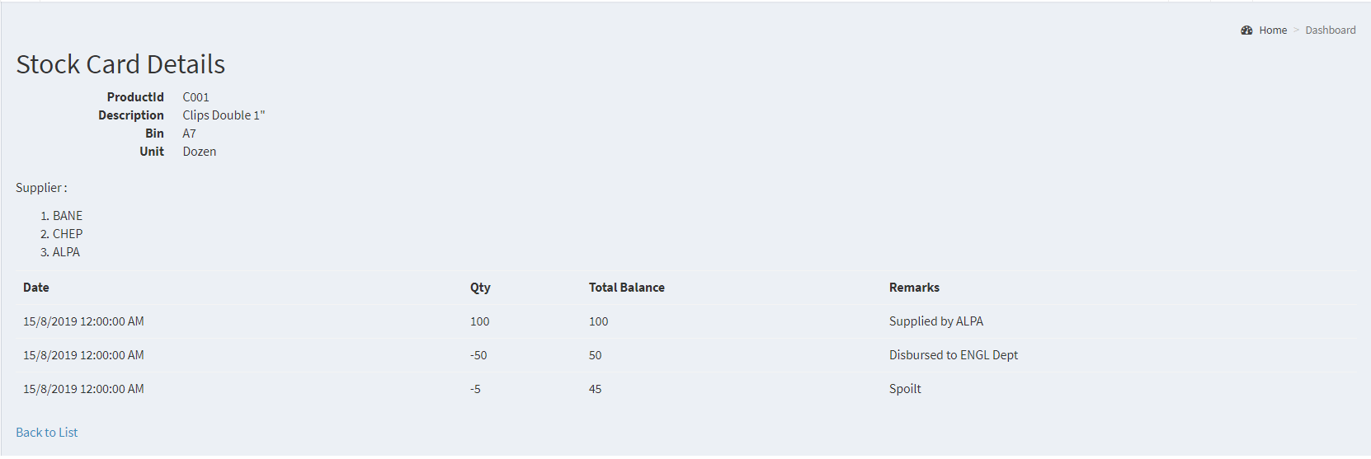

## Add a New Stationery

There are cases where Logic University would like to supply new item. In such a situation, the user will be able to create a new item by clicking the “Add new item” button in the product list page. It will lead to the page where user can enter the desired details and save them.

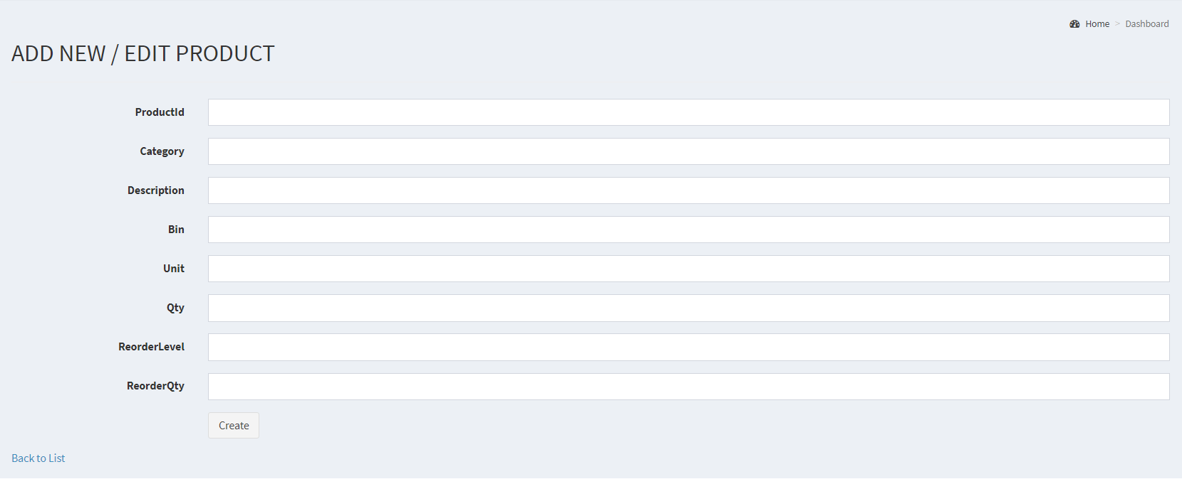

# Supplier List

## View Supplier List

User will be able to view the supplier details where it stores the information of all suppliers.

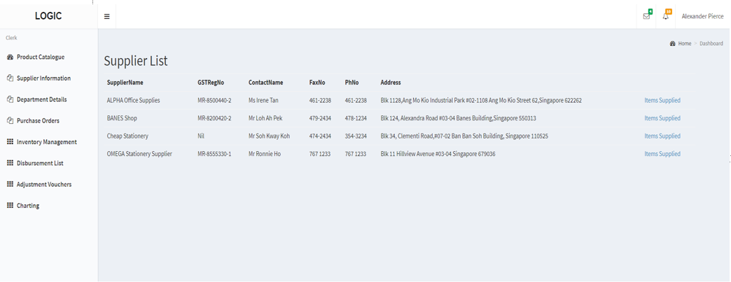

## View list of stationery supplied by a particular supplier

Click on the ‘Items supplied’ by each of the supplier to view the detailed stationery list. Each supplier supplies different stationeries and user will be able to view the list of stationery provided by this supplier.

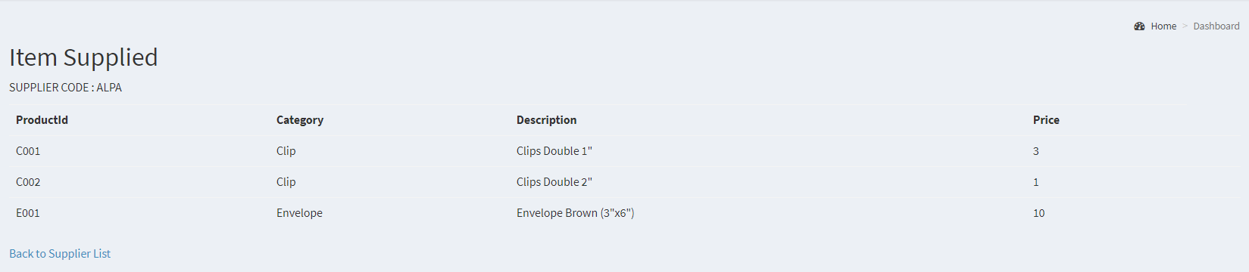

# Department Details

## View Department details

User will be able to view the department details of Logic University. User may also refer to the collection point of each department in case they need to refer, as well as the representative and head name of each department.

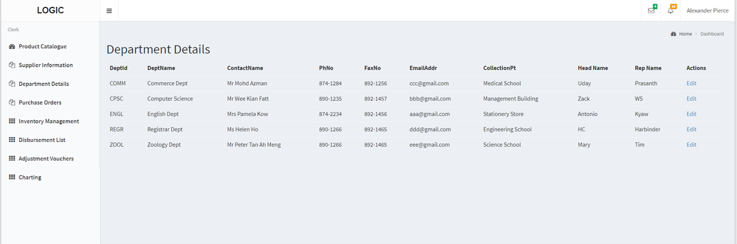

## Edit Department Details

User may also modify certain parts of the department details for the latest department information. Note that collection point, head name and representative name are prohibited from modification. Any changes on those parts will be done by each of the respective department and changes will be reflected on the department details.

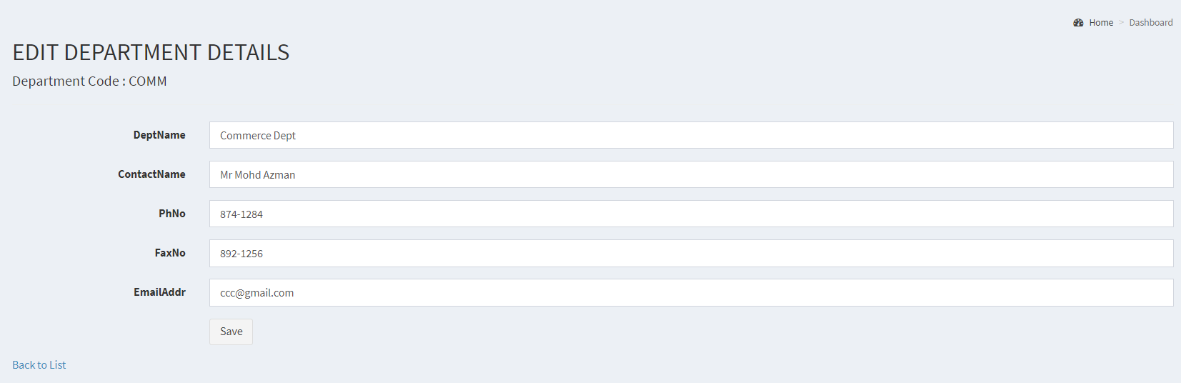

# Purchase Orders

On clicking on the link for purchase orders, the store clerk will be brought to the following page.

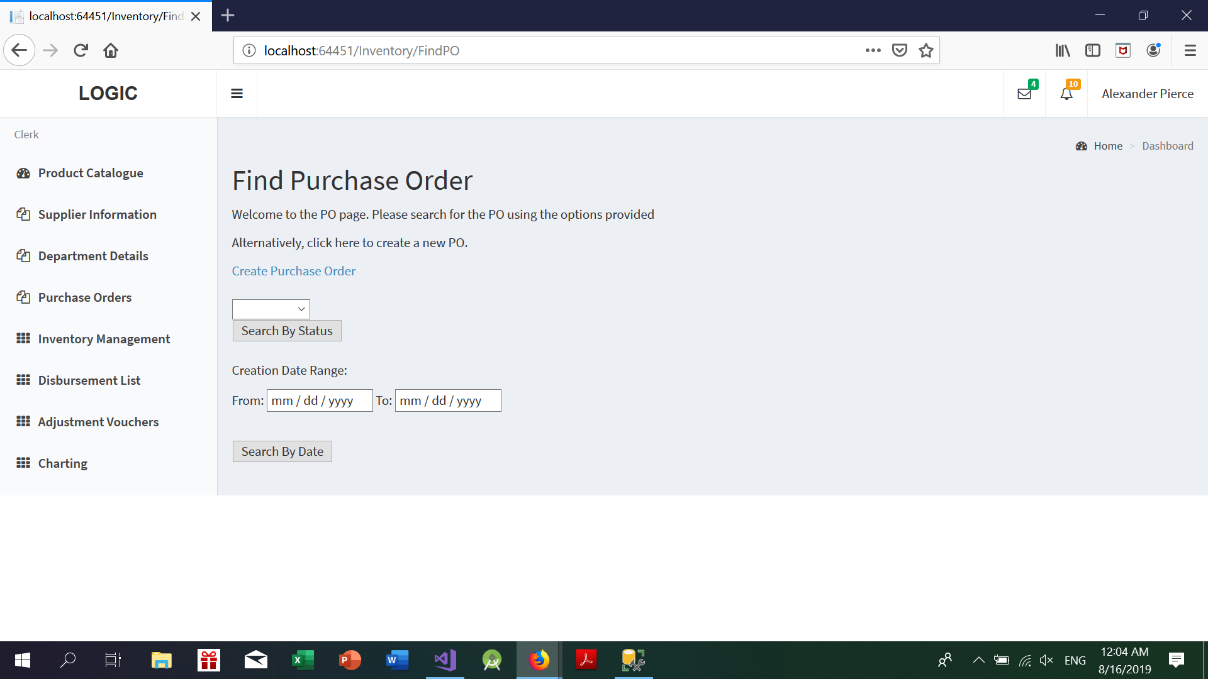

From here, the user can either choose to: (i) Look for purchase orders or (ii) Create a new purchase order.

## 

## Find Purchase Orders

Search for your PO using ONE of the forms provided. The criteria the user can choose from are:

* By Date Range
* By Status (Approved, Pending, Rejected)

If any of the PO’s in the database match the search criteria, they will be displayed in the search.

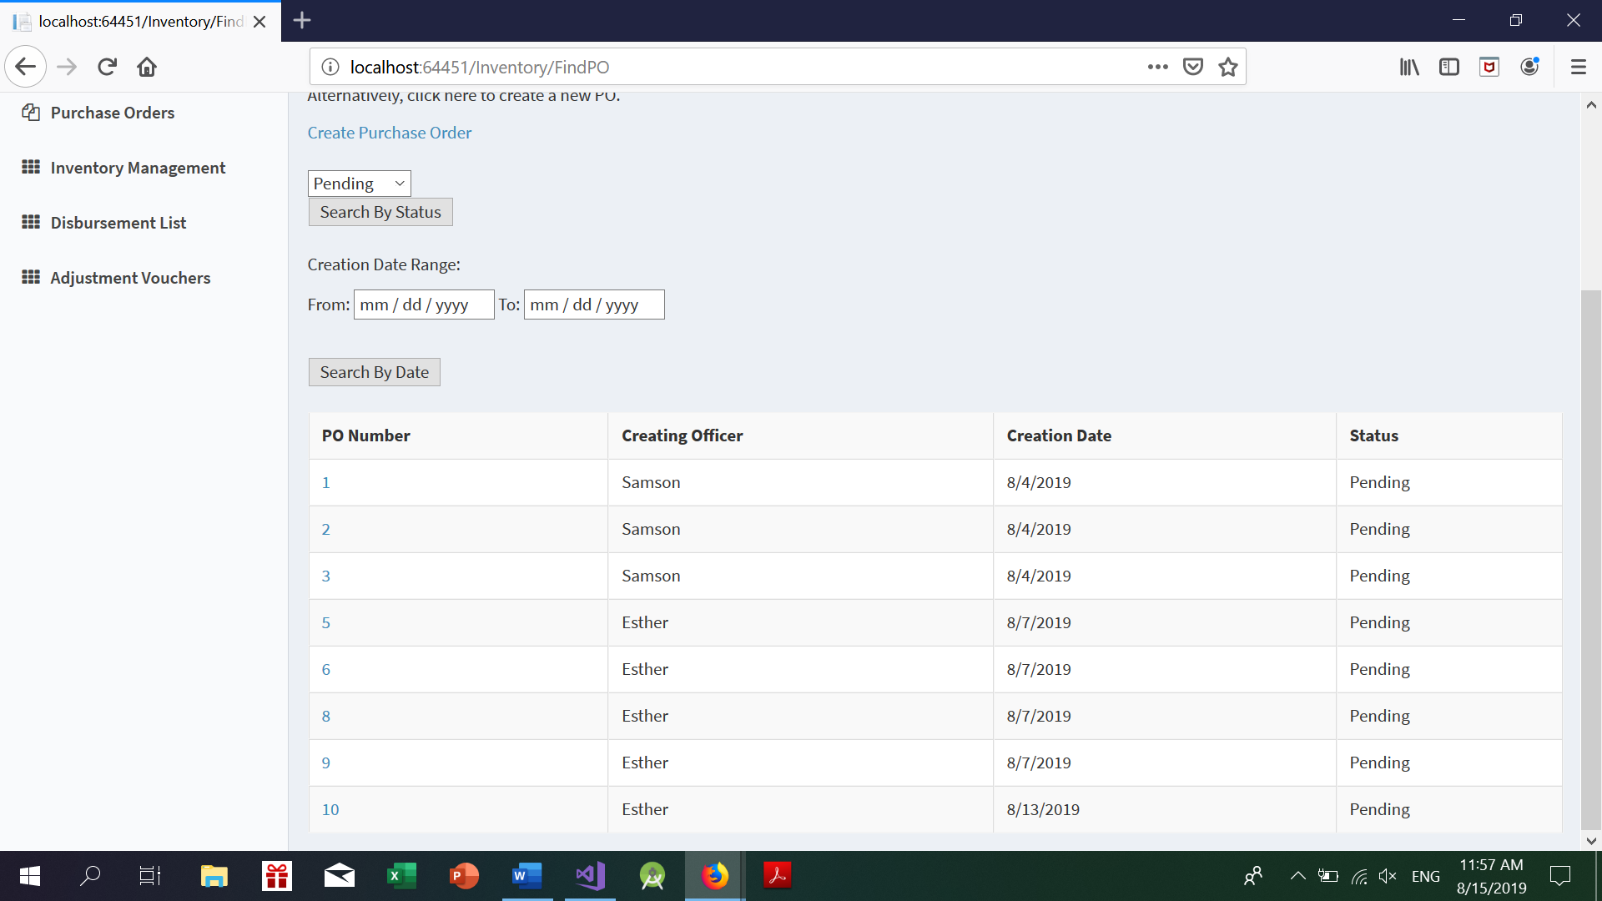

*Example of a search done by PO status*

Click on the PO number to see the specific details of the Purchase order.

## Purchase Order Details

Here is a sample of a detailed PO. (Note that the approved date only appears when the status is approved.

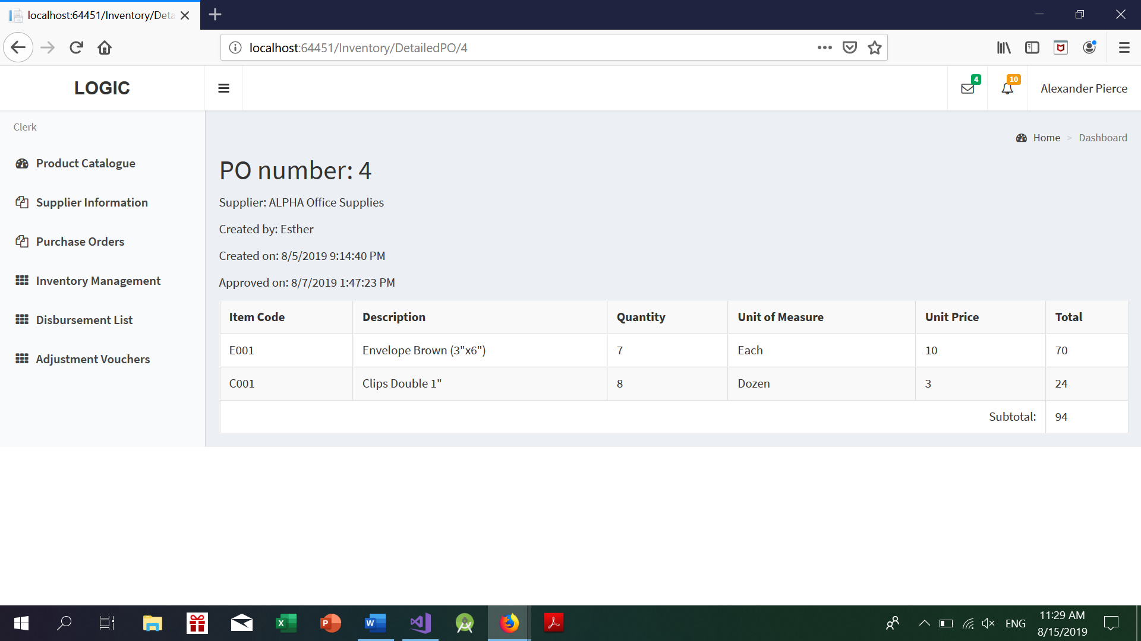

## Create Purchase Order

To create a new purchase order, please click on the Create Purchase order link which the next screen will be shown.

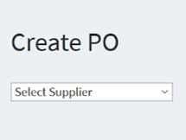

A new empty page for the PO will show up. Please select the respective supplier to continue seeing the fields to enter the necessary information.

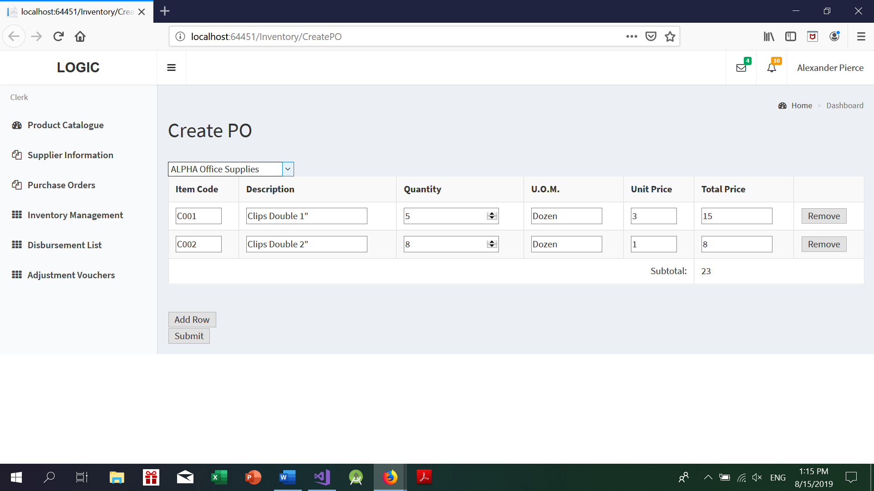

Add Row -> Adds a row to the table for entering details.

Remove-> Deletes the row.

Editable fields -> Item Code (required), Quantity (required). The rest of the fields will be auto populated.

Note that if item not supplied by this current supplier is added, the submit button will be disabled.

Once all fields are filled in correctly, press the submit button to send the PO to the supervisor for approval.

# 

# Inventory Management

On clicking of the Inventory management link, a sub-menu will appear, showing the various functions: Receive Inventory from Suppliers, Withdraw Inventory from Store, View Requests, View Inventory.

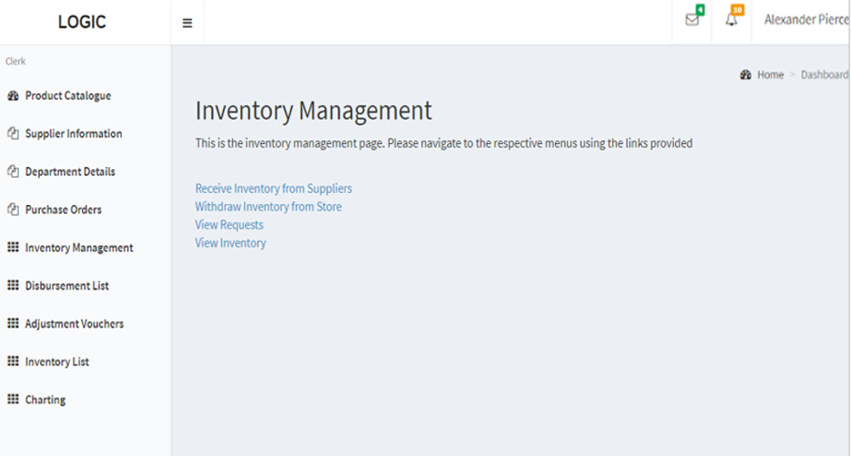

## Receiving Inventory from suppliers

When receiving items from a supplier in a delivery, click on the “Receive Inventory from Suppliers” link to update. Clicking on the link will bring the clerk to the following page.

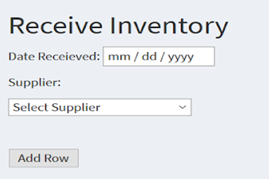

The user has to select the supplier from the drop-down list before seeing the table to add information.

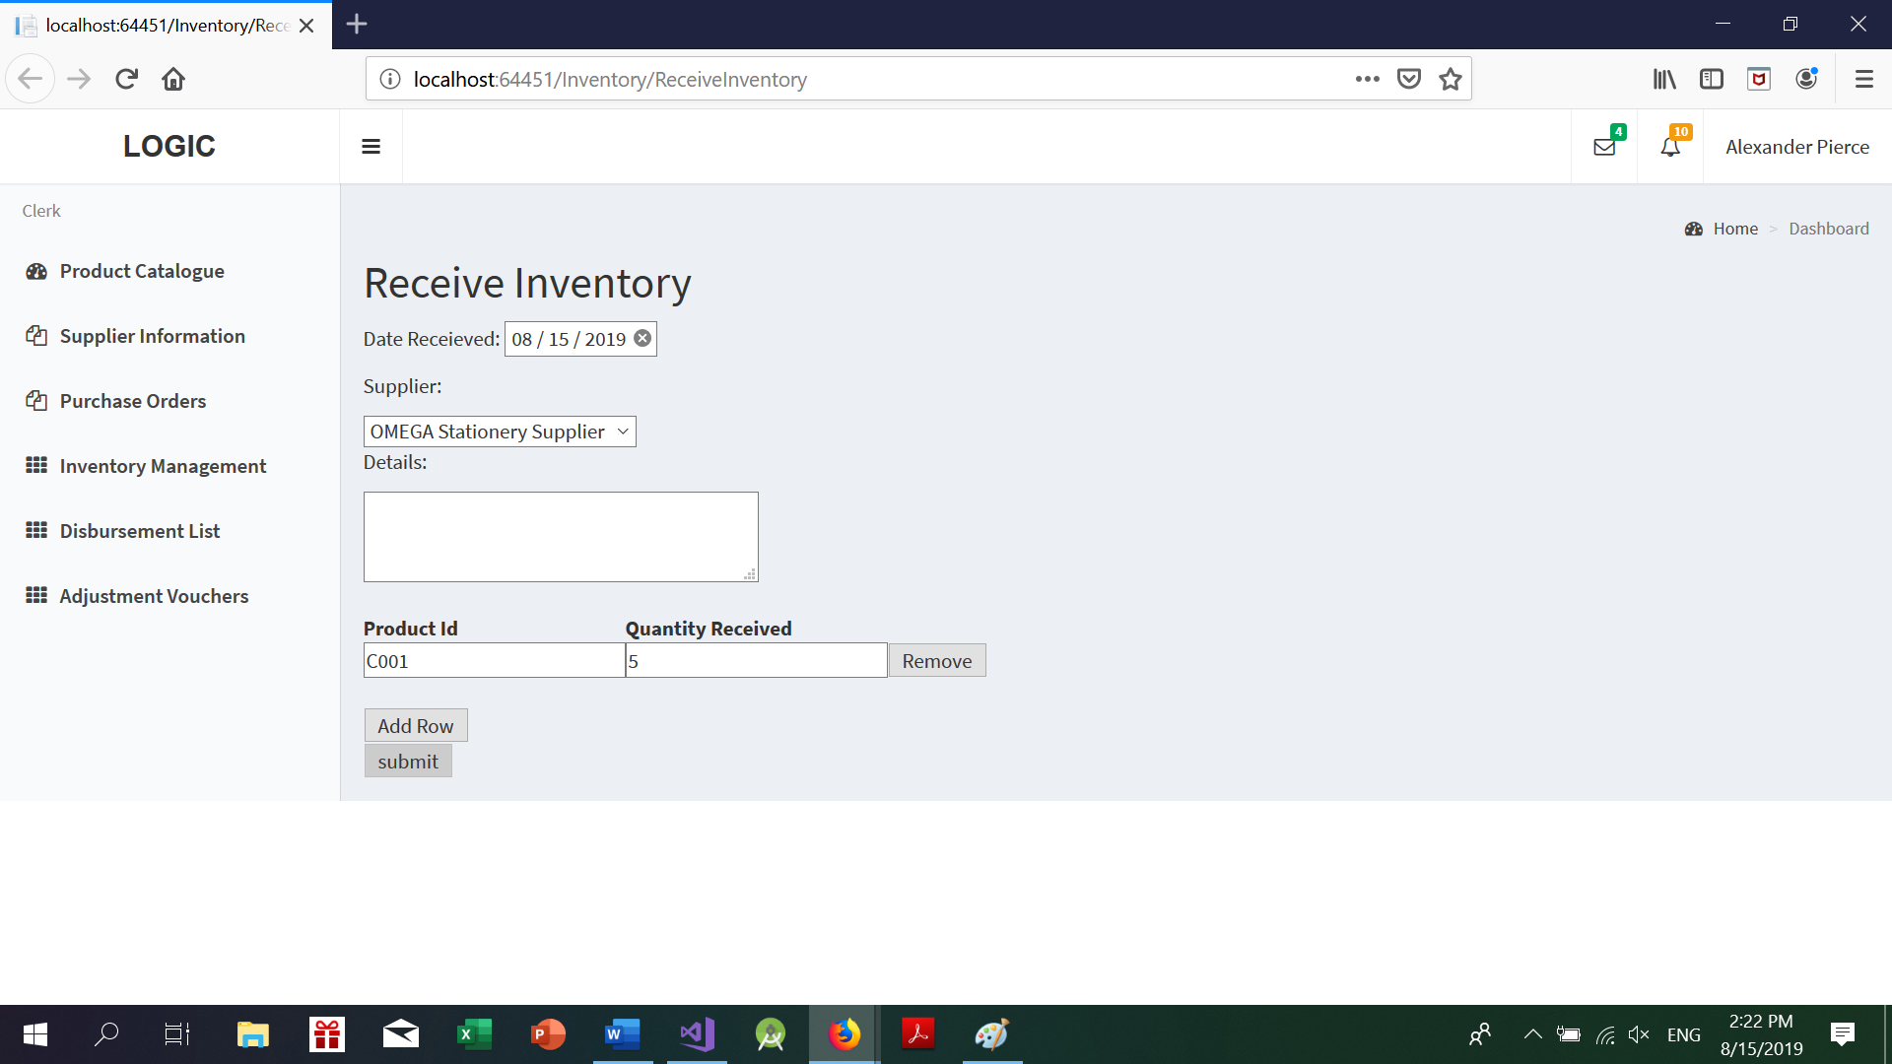

Add Row -> Adds an additional row to add data.

Remove -> Removes the current row

Required fields -> Product Id and Quantity Received. Note that if an item code not supplied to a supplier, the submit button will be disabled.

The user can then proceed to enter the item codes and quantities into the system before clicking on the submit button. For every item code entered, the quantities will be updated accordingly.

## Withdrawing items for weekly disbursement

To withdraw items from the store for weekly disbursements, click on the “Withdraw inventory from store” link.

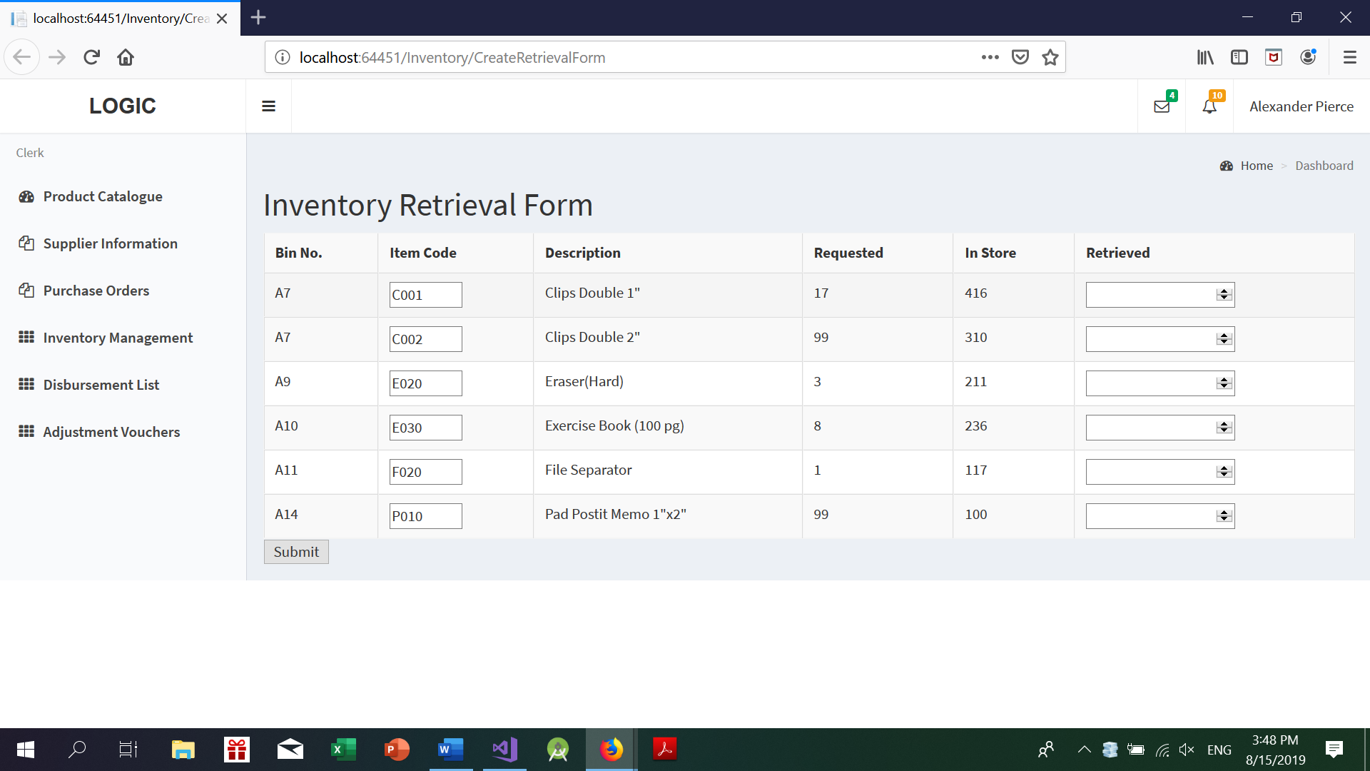

The number of items requested is the total requested by all departments. Note that store clerk can only withdraw as many items as that displayed in the store.

On submitting the inventory retrieval form, the stock transaction and item quantities will be updated. At the same time, disbursement lists for the departments would be generated as well.

## Generate and view the Consolidated Request Form

Clicking on the View Request link after the requests submission date is closed for that particular week, the store clerk generates the Orders form by selecting FromDate and ToDate which contains the new orders submitted for that week with status “new” and also the pending orders which were not fulfilled due to unavailability of the stock from the previous weeks with status “Outstanding”. After the Requests list is displayed ,store clerk can click on each individual request to view the items present in the request and also view the number of quantity requested for each item respectively.

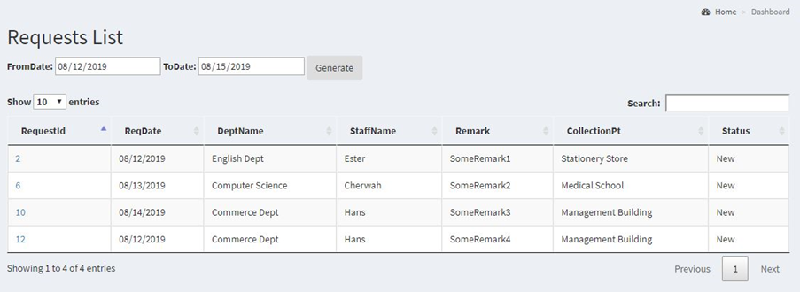

After the store clerk clicks on the particular request Id, he gets to see the items and their details within the respective Request.

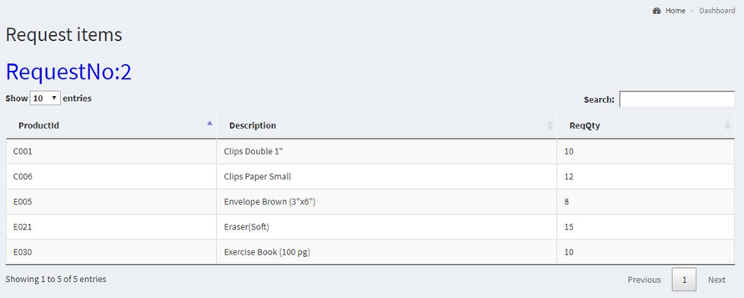

## View Inventory

Upon clicking the ‘view inventory’ button, store clerk will be able to view all the quantity for the stationery. There will be a search bar for store clerk to search for a particular item as well.

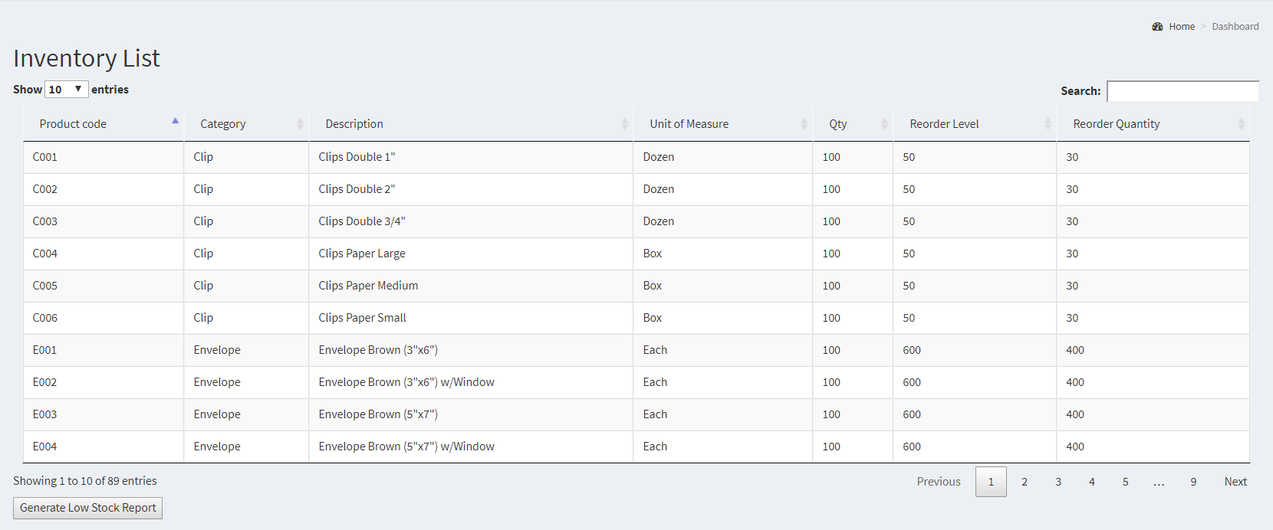

# 

## View Low Stock Inventory

Store clerk can view the low stock items by clicking on the Generate Low Stock Report Button in the Inventory List form.

All the items which has “Qty” less than “ReOrder Level” are displayed in this low stock form.The Store clerk can make a purchase of the products which are in the low stock list with quantity of “Reorder Quantity” for the respective Item.

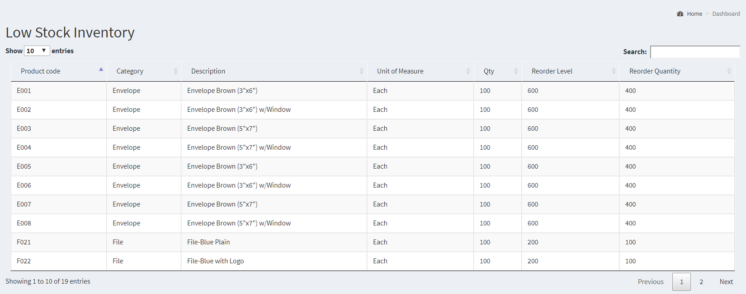

# Disbursement List

To get to the disbursement list page, click on the disbursement list link. Following the link will take the clerk to the page to search for disbursements.

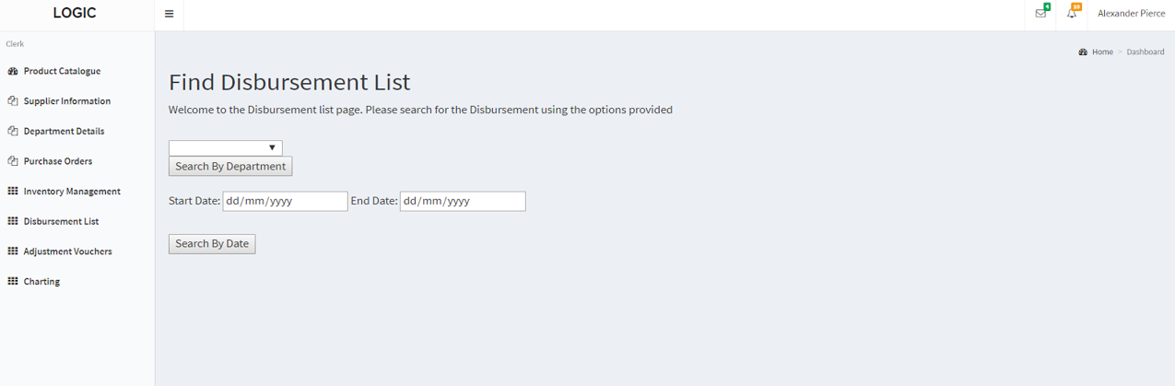

## Finding Disbursement Lists

Entering either creation date of the disbursement, or the status of the disbursement to begin searching for the list

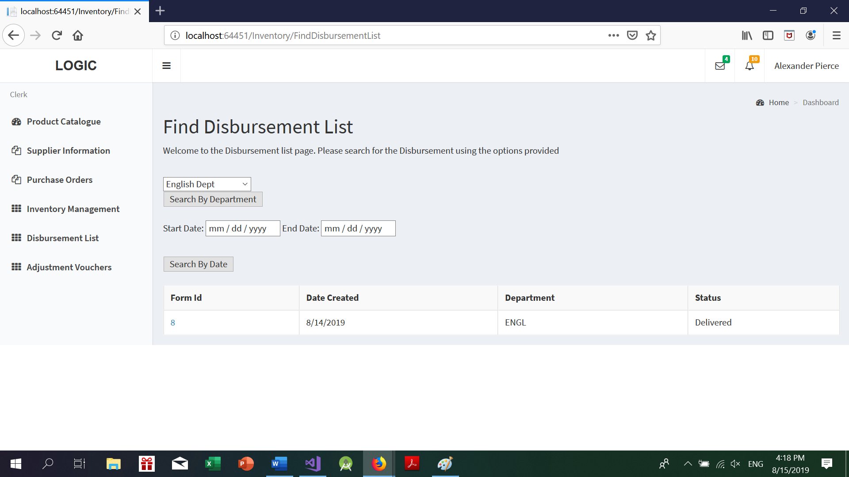

*Example of a search by Department Disbursement screen.*

Clicking on the form number will show a detailed view of the disbursement list. The view varies slightly depending on whether or not the form has been marked as delivered.

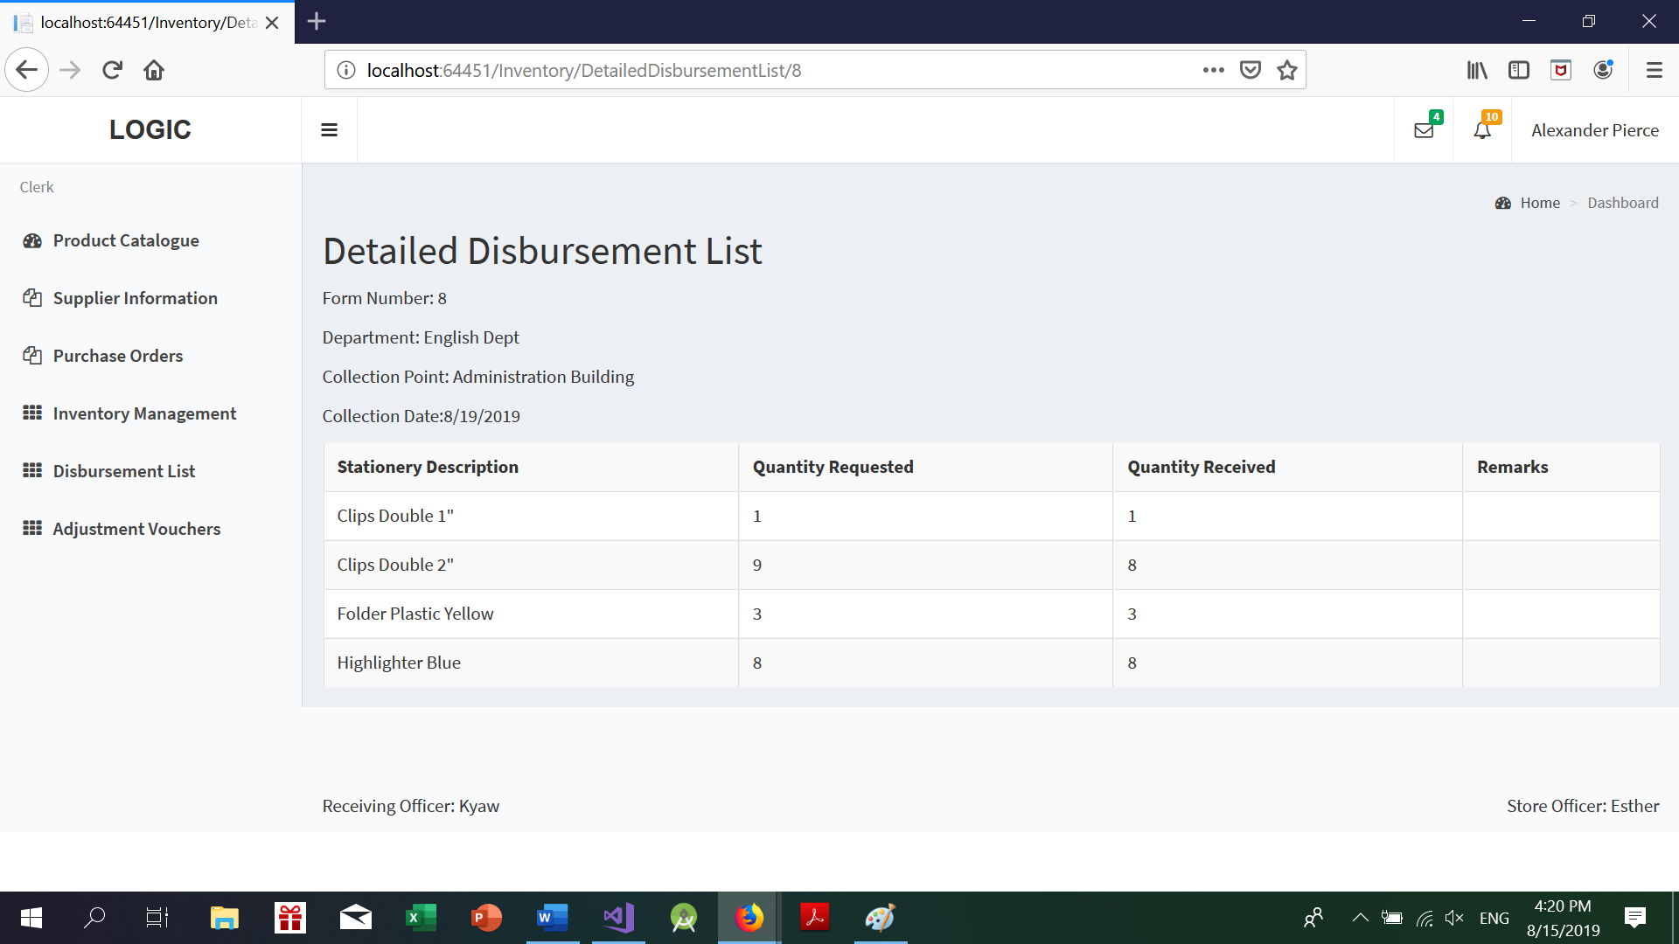

*Example of a Disbursement which has already been delivered*

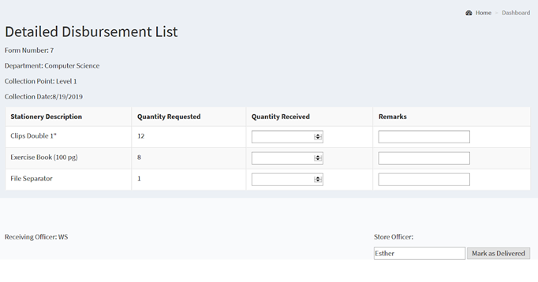

*Example of an undelivered disbursement list*

If a disbursement has yet to be delivered, the store clerk will be to print this form to bring to the collection point for signing with the department rep. After the signing is completed, the store clerk can proceed to update the quantities delivered, together with remarks (if any).

Required fields: Quantity Received.

Once the clerk has ensured the form is filled according to the hard copy, he can proceed to mark the disbursement as delivered. Note that once clicked, changes CANNOT BE MADE to the disbursement form thereafter.

Doing so causes a number of things to happen at once:

1. The disbursement will now have the status ‘Delivered’

2. The requests that have been collated for this department will be marked as ‘Delivered’.

3. If the quantity received is less than the quantity requested, a new OUTSTANDING request will be generated automatically. It will be generated by the department representative for the week.

# 

# 

# 

# 

# 

# 

# 

# 

# 

# 

# Create Adjustment Voucher

Store clerk can create the adjustment voucher if there are any adjustments or discrepancies .He navigates to Adjustments Vouchers screen and click on the Create Voucher which will navigate to the Adjustment voucher form.

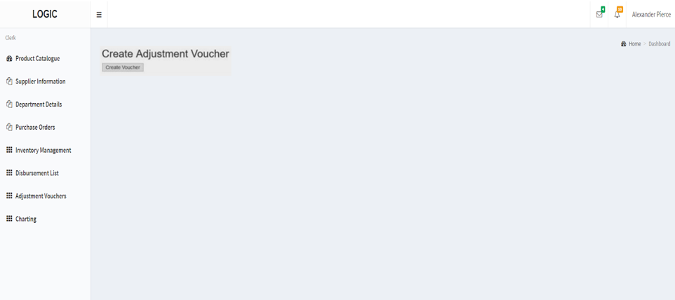

## Create Adjustment Voucher Form

Once the store clerk clicks on the create Create Voucher button ,it navigates to the create Adjustment Voucher form page.The Store Clerk can add the items from the dropdown list and the quantity to be adjusted for that particular item.He can click on the “addnew” button which gives other row for the clerk to add another item.Once all the items are added in the form the Store clerk can click on the “Confirm and Send Request” button.Depending on the Total price of the voucher ,request goes to Manager if it is Greater than 250$ and to the supervisor if it is Less than 250$.

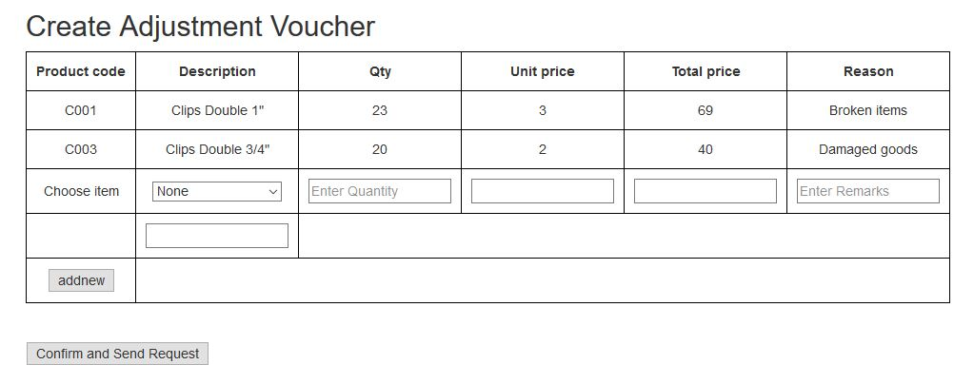

# Stationery Trend Analysis and Prediction

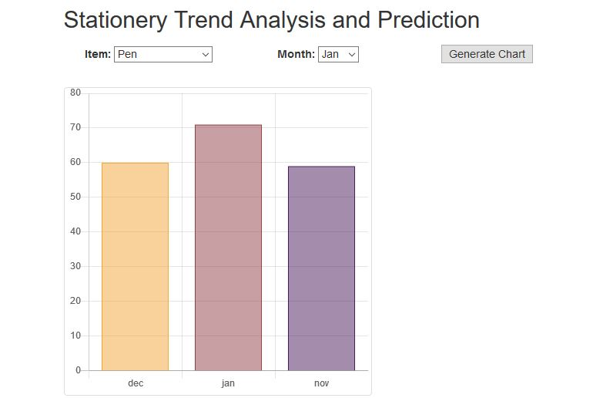

The page allows the store clerk to make predictive analysis by selecting the item category and the month. For example, if the user chooses the month, he can measure the quantity of items sold for the previous two months along with a predicted quantity for the month chosen. By checking the predicted quantity, the clerk can alter the reorder level of this particular item based on the demand. The “Generate chart” button is used to generate bar charts as per the predicted data using the previous years data as a basis for generating the model. The quantity can be viewed by hovering the mouse over the chart.